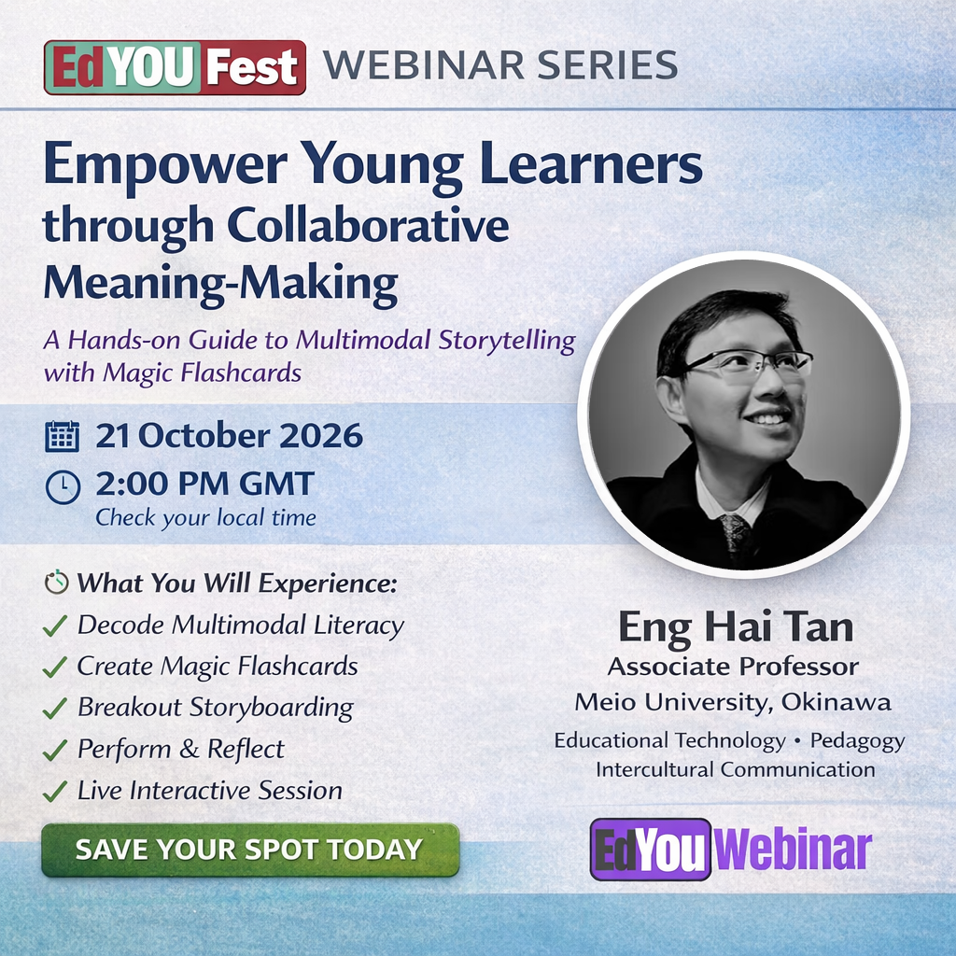

ABSTRACT
Most children have a story inside them; they just need more than a blank page to tell it. Real literacy happens when children can use their hands, their voices, and their imagination all at once. That’s the heart of Multimodal Literacy, and this workshop shows you exactly how to make it work in your classroom.
In this 70-minute interactive workshop, you’ll discover Magic Flashcards, a hands-on tool that uses a simple “flip” to create cinematic scene transitions between story frames. It gives students a concrete way to sequence ideas, negotiate plot decisions with their peers, and find their own storytelling voice. By anchoring learning in peer collaboration and shared meaning-making, students move naturally toward the top of Bloom’s Taxonomy - from recalling words to creating original stories together.
During this hands-on session, you will:
- Decode Multimodal Literacy: understand how combining visual, spatial, and oral modes accelerates language acquisition and deepens engagement
- Craft the Magic: build your own Magic Flashcard and grasp the simple design that makes it so powerful for visual storytelling
- Collaborate in the Third Space: work in breakout teams to move a narrative from a graphic organiser to a multi-frame storyboard
- Perform & Reflect: present your group’s story and experience firsthand how students can perform their learning

To ensure a seamless experience, please join via laptop/tablet with a functioning camera and have these materials on your desk:
- The Canvas: 2 sheets of A4 cardstock or drawing block paper.
- The Tools: Scissors and coloured pencils/markers.
- The Digital Hub: Access to Google Docs for group storyboarding.

BIOGRAPHY
Eng Hai Tan has over three decades of teaching experience ranging from elementary school to tertiary education. He taught educational psychology at the Singapore National Institute of Education prior to working as an administrator in an English immersion school in Japan. He is currently an Associate Professor at Meio University in Okinawa. His research interests include pedagogy, educational technology, and intercultural communication. He is passionate about fostering global understanding through education and aims to prepare students for an increasingly interconnected world.

